**REACT Fundamental Project** Project Assigned: 23-May-2019 Project Deadline: 3-Jun-2019

There are three shelves of books as following:

* Currently Reading
* Want to Read
* Read
* None

Each shelve is having its own status/ state. Each book is showing its picture, title and author name.

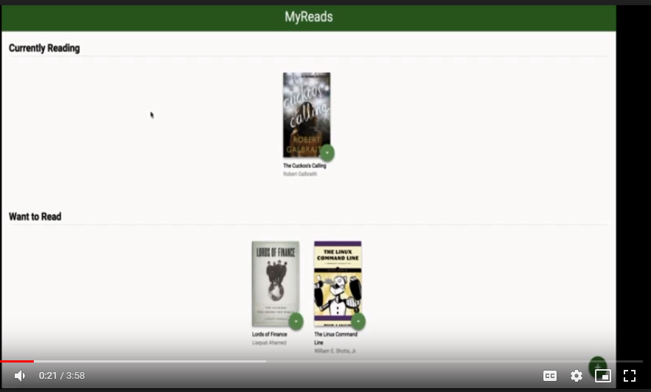

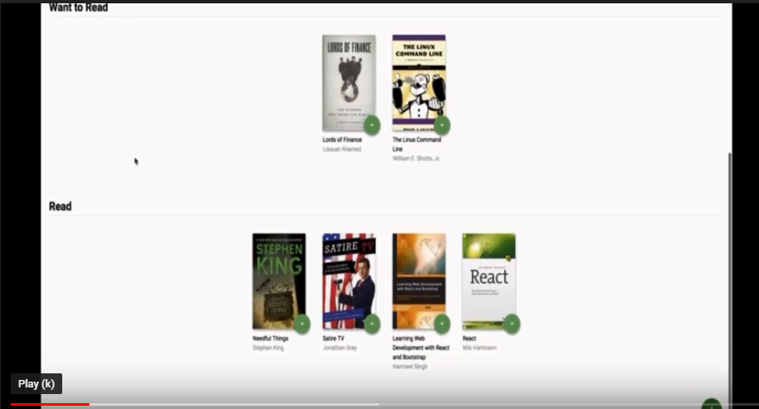

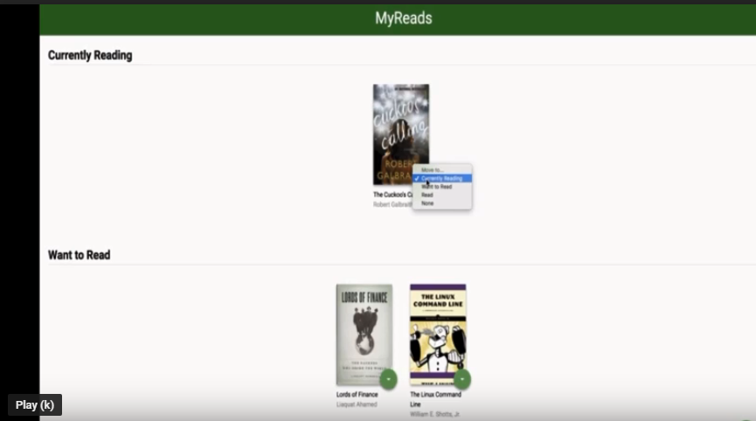

* ‘None’ means we wanted to send the book back to the library.
* Library can be invoked when clicking on the button with ‘+’ sign on the right bottom corner.
* A separate page will be invoked through routing. It should have search area where book(s) will be displayed against search criteria.
* All books should be appearing in the library irrespective of their statuses, meaning; if a book is with ‘Currently Reading’ status it remains appear in the library as well as in its corresponding shelve which is for this case is ‘Currently Reading’.
* Status can be set from any shelve or directly from the library. There is a back button on the Library page which brings back to the main page.

Note: app.css is already available.